# Enterprise

Create a Web page (HTML5 + CSS3) that looks and behaves like the screenshot below:

### Output

The output should be valid **HTML5** + **CSS3** + **images** that implement the above web page.

### Constraints

* Use font Helvetica for the text
* The site should open correctly in the latest version of Chrome

# DigiMedia

You are given an unresponsive website (**HTML** + **CSS** + images). Your task is to **make the site responsive**.

The site layout should change according to the browser viewport / screen size.

You need to implement 1 layout: **width <= 600px**. The figures below represent this layout:

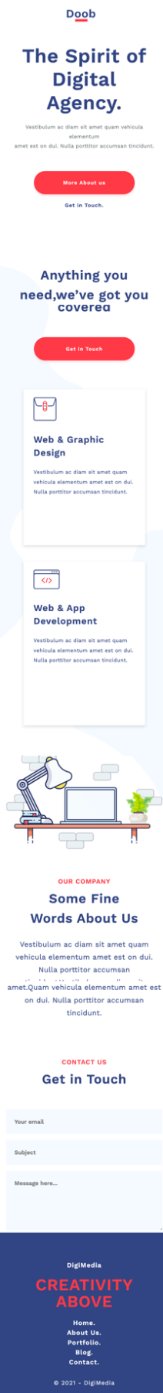

## Output

The output should be valid **HTML5** + **CSS3** + **images** that implement the above responsive site.

## Constraints

* You should write styles in theresponsive.css file (CSS folder).

# Portfolio

Create a Web page (HTML5 + CSS3 + images) that looks and behaves like the screenshot below:

You are given the above screenshots + all required images.

### Output

The output should be valid **HTML5** + **CSS3** + **images** that implement the above web page.

### Constraints

* Use Font Awesome for the icons
* Use font Raleway **(**<https://fonts.google.com/specimen/Raleway>**)**
* The site should open correctly in the latest version of Chrome